Online Shopping System: FootFusion

Use-Case Specification: Add Payment Methods

Version <1.0>

Revision History
Date | Version | Description | Author
22/11/2024 | 1.0 | Final Draft | Nguyen Minh Duc

Table of Contents
1. Add Payment Methods 4
1.1 Brief Description 4
2. Flow of Events 4
2.1 Basic Flow 4
2.2 Alternative Flows 4
2.2.1 Addition Failed 4
2.2.2 Added Successfully 4
3. Special Requirements 4
4. Preconditions 4
5. Postconditions 4
5.1 Addition Failed 4
5.2 Added Successfully 4
6. Extension Points 4
7. Prototype 4

Use-Case Specification: Add Payment Methods

Add Payment Methods

Brief Description
The purpose of the use-case “Add Payment Methods” is to define the steps of adding a new payment method to the system of FootFusion. The administrator can add new methods easily and correctly.

Flow of Events

Basic Flow
After logging in, the administrator goes to the dashboard column's payment methods management page. He or she then fills up the "Add payment methods" section with the details and description of the new methods. At this stage, every piece of data will be stored in the database and shown off-screen.

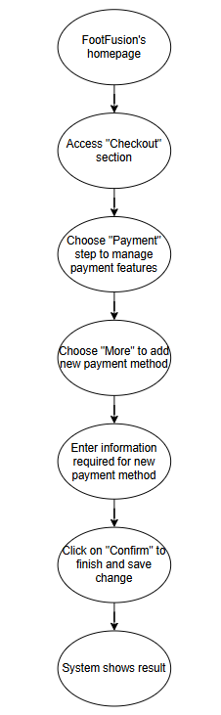

Alternative Flows

Addition Failed
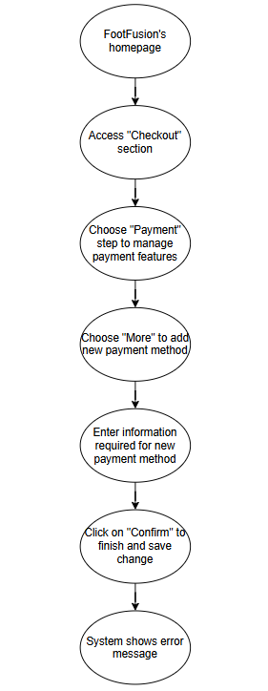

Added Successfully
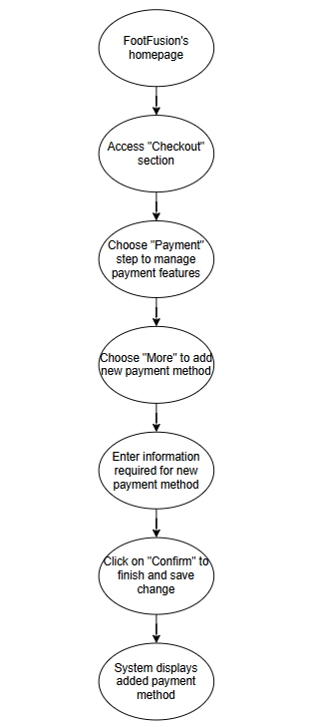

Special Requirements
The administrator has basic knowledge of operating computers and user interfaces.

Preconditions
The administrator has logged in to an administrator account.

Postconditions

Addition Failed
If the system failed to add the new payment method, show error message.

Added Successfully
If the system added the new payment method successfully, refresh the page with the new method in the method’s list.

Extension Points
There is no extension point.

Prototype

Figure 1: After managing the “Delivery” step or directly accessing the “Payment” step, the System will display this “Payment” step to manage payment methods

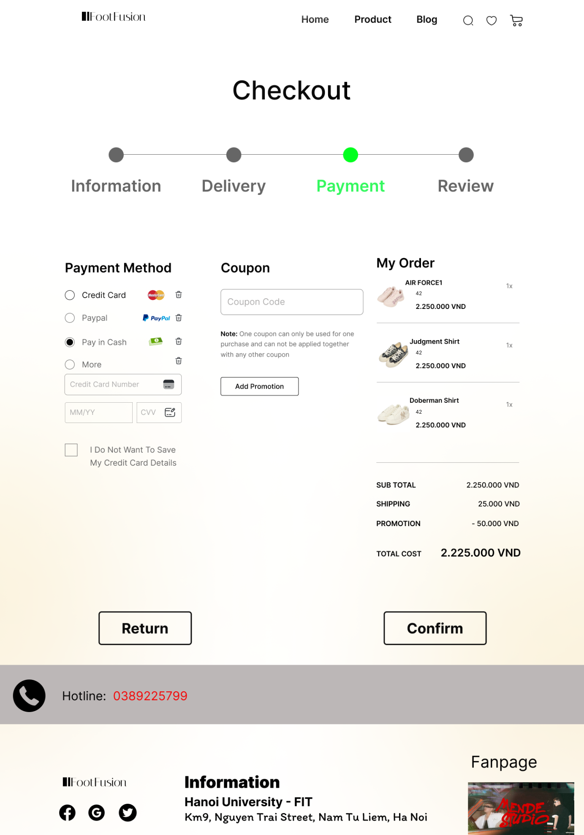

Figure 2: Some payment methods for the order that can be chosen by clicking on the corresponding circle at the left. Obviously, administrator can add another Payment method by choosing “More” and entering Card information.

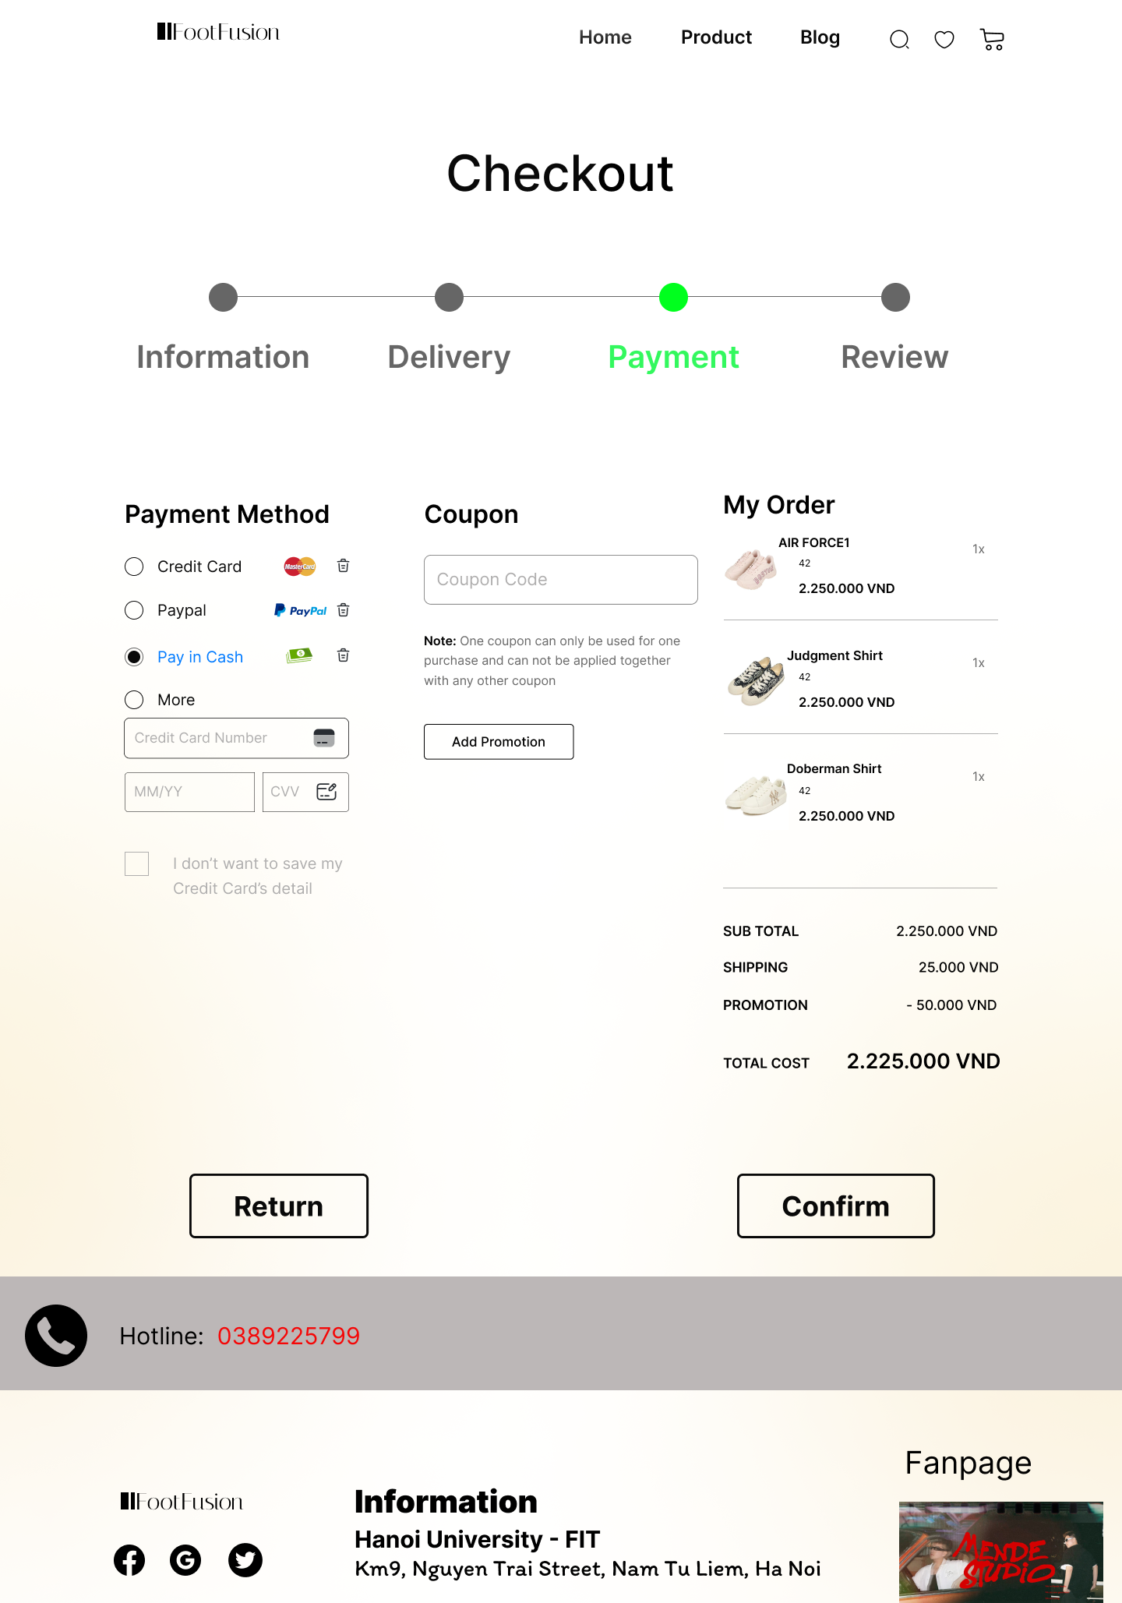

Figure 3: After adding new method, administrator clicks on “Confirm” button to save change and move to the last step

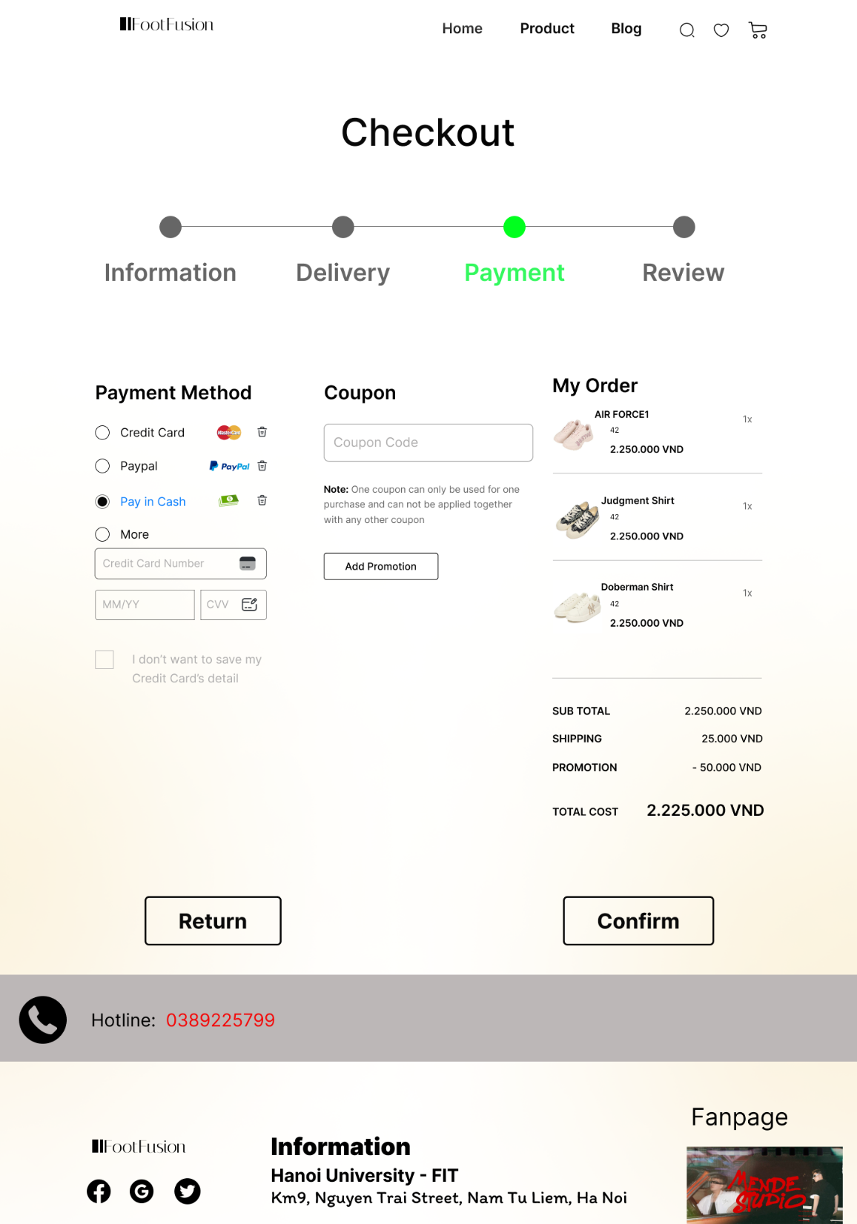
“Confirm” button

